COB Workflow Flowcharts – Old and New
Nov 10, 2026 · @cherry
Each claim runs top to bottom. An arrow to the right means the check was true: the claim leaves the flow there, gets a report row, and the bot moves to the next claim. Read from the workflow JSON files; nothing was run.

Old workflow (Chris's)
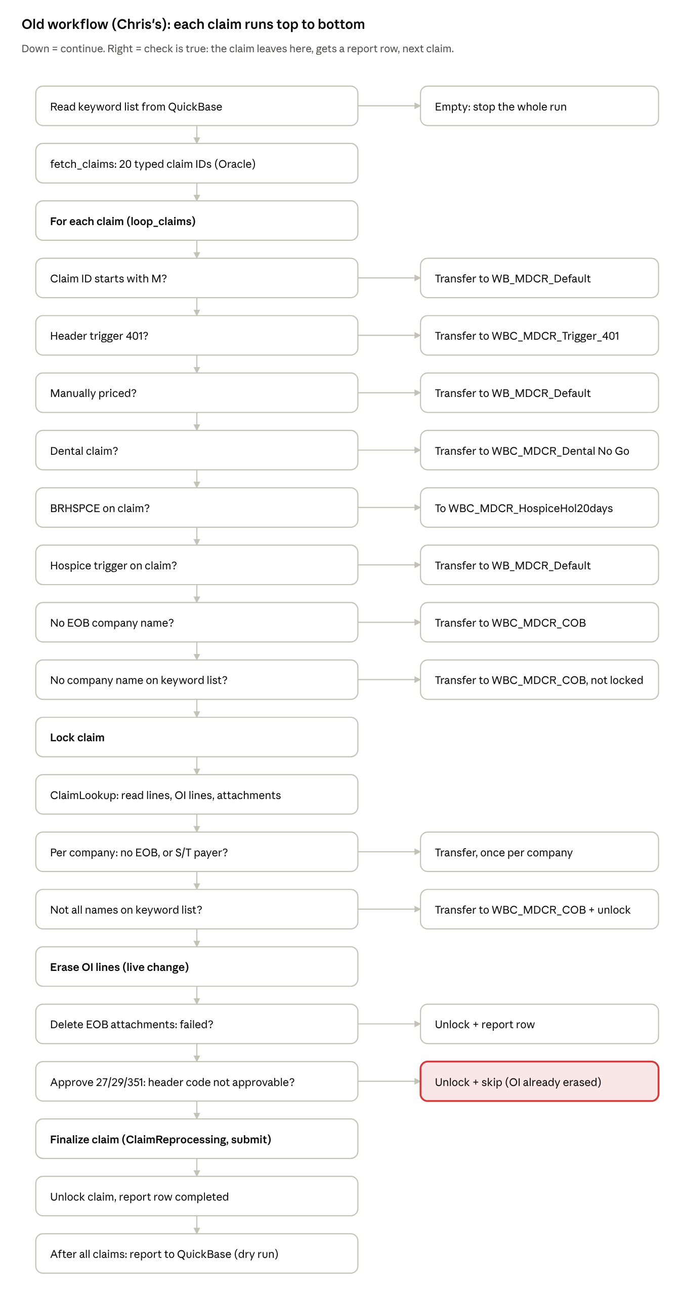
old workflow (cob_happy_path_live_v3) · 21 steps
It handled 27, 29 and 351 the same way. The red box is the old known issue: a claim with an unapprovable header code was skipped only after its OI lines were erased.

New workflow
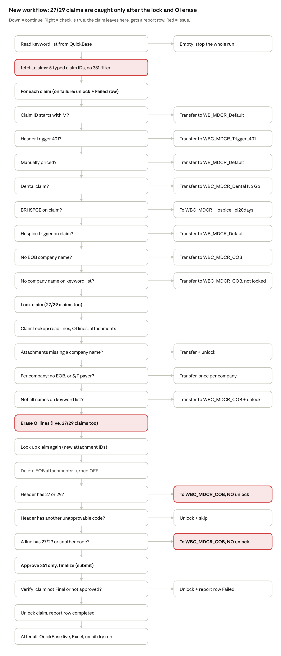
new workflow (cob_happy_path_live.workflow v0.2.0) · 26 steps
The red boxes are the issues: the claim list is hardcoded, 27/29 claims are locked and erased before they are caught, and the two 27/29 transfers have no unlock after them. On QA2, 79 bot 1280 claims have 351 together with 27 or 29 and would take this path.

